Chapter 17, Solution 44.

Design a problem to help other students to better understand how to find the rms voltage across and the rms current through an electrical element given a Fourier series for both the current and the voltage. In addition, have them calculate the average power delivered to the element and the power spectrum.

Although there are many ways to solve this problem, this is an example based on the same kind of problem asked in the third edition.

Problem

The voltage and current through an element are respectively

v(t) = [30 cos (t + 35°) + 10cos(2t – 55˚) + 4 cos(3t - 10°)] V

i(t) = [2 cos (t–10˚) + cos(2t – 10°)] A

- Find the average power delivered to the element
- Plot the power spectrum.

Solution

(a) 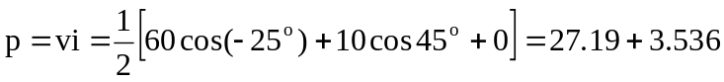 = 30.73 W.

(b) The power spectrum is shown below.

p 27.19

3.536

0 1 2 3

